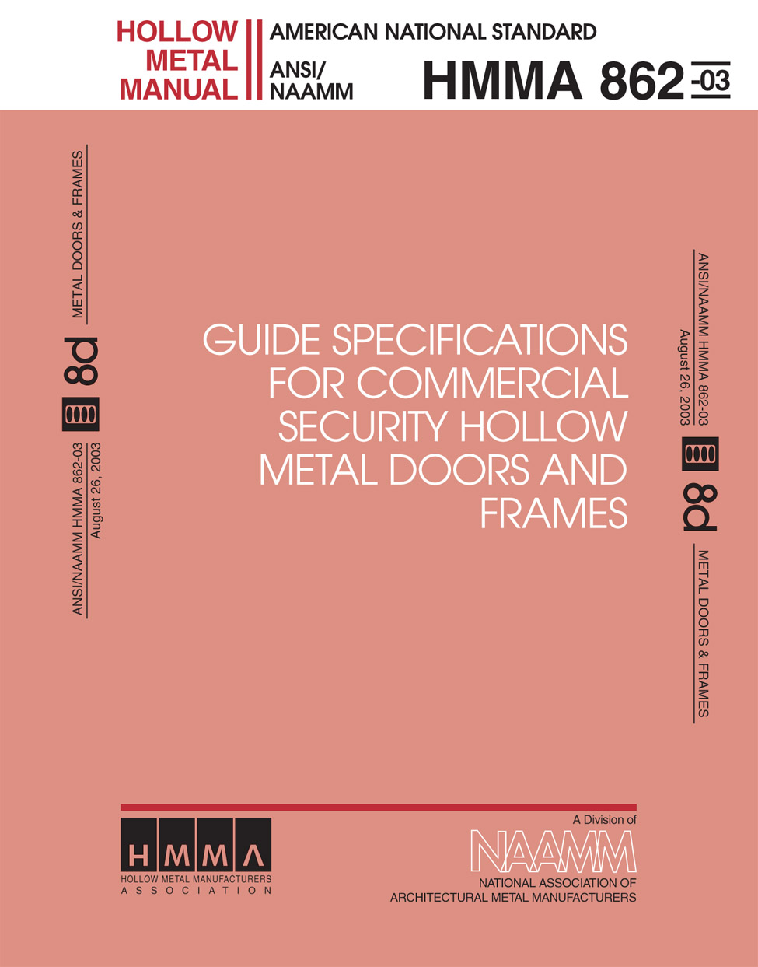

Hollow Metal Manufacturers Association
Division of the National Association of Architectural Metal Manufacturers

This manual was developed by representative members of the Hollow Metal Manufacturers Association Division (HMMA) of the National Association of Architectural Metal Manufacturers (NAAMM) to provide information and guidance on the selection of hardware for hollow metal doors and frames. This manual contains advisory information only and is published as a public service by NAAMM and its HMMA Division.

NAAMM AND ITS HMMA DIVISION DISCLAIM ALL LIABILITY OF ANY KIND FOR THE USE, APPLICATION OR ADAPTATION OF MATERIAL PUBLISHED IN THIS STANDARD.

Purchasers of NAAMM Standards may receive current information on all NAAMM Standards by calling or writing the National Association of Architectural Metal Manufacturers.

Copyright @1985, 1987
National Association of Architectural Metal Manufacturers
8 South Michigan Avenue Chicago, Illinois 60603

FOREWORD
NAAMM Specification HMMA 861-87 is written to provide the optimum mixture of protection, durability security, quality and economy normal to most application of steel doors and frames. However, there will exist cases due to high susceptibility to vandalism, break in, and theft in which security is a paramount concern. A few examples of such are entrances and back doors of businesses, storerooms, warehouses, apartments, and condominium units. This Standard, HMMA 862-87, has been developed to meet requirements where security is a paramount concern.
It is necessary when writing a security specification to keep in mind the security aspects of the entire opening - door, frame, hardware, glazing, and wall construction. It serves no purpose to specify security hollow metal combined with standard commercial hardware, glazing, and/or application. It is for this reason, although not professing expertise, we highlight some pertinent information in these areas critical to your security specifications. We recommend that you consult the professionals of these trades to assist you in greater detail.
Hardware Recommendations. Reference ANSI A 156 Series
A. Butts and Hinges: Due to the weight and critical service expected from security hollow metal doors, heavy weight-ball bearing full mortise hinges (or the equivalent hinge in other types; example, hall mortise, full surface, etc.) should be specified. A minimum of 2 pair of 41/2" X 4 1/2" full mortise hinges should be used. For very heavy or over sized security doors, consideration should be given to using such special hinges as:
Extra heavy weight full mortise hinges, size 8" X 6" (for doors up to 600 lbs. in weight)
Double weight ball-bearing, size 5" (for doors up to 800 lbs. weight)
Triple weight ball bearing. size 5 - (for diners up to 2 000 tbs. weight)
It is recommenced a "security stud" type hinge be used in conjunction with non-removable pin feature.
B. Locks and Lock Trim: Due to special requirements of security hollow metal doors, the following should be considered regarding locking hardware.
If a dead bolt function is specified for mortise locks, Series 1,000, Grade 1, it should be a minimum 1" throw with hardened inserts.
If no key function is required on the outside of the door, the outside face of the door should not be cut for cylinder or thumb turn.
If a key function is required, a heavy cast or extruded lock trim design should be considered that is attached with either thru-bolts from the inside, concealed fasteners or special fasteners, like spanner headscrews, to prevent removal of lockset components from the outside to circumvent the lock. Lock cylinder(s) should meet UL 437.
When cylinders are used they should be protected against forced removal by suitable cylinder guards. Under no circumstances should a bored lock, Series 4,000 (cylindrical, key-in knob or lock-in knob) be installed in a security hollow metal door since this type of lockset does not provide even a minimum acceptable level of security.
C. Door Controls (closers): Since many situations require that a security hollow metal door be self-closing and self-locking, all doors of this type should be properly reinforced. Due to heavy weight of these doors, suitable door closers should be considered for safe operation. For pairs of security doors, a stop-strip threshold should be securely fastened to the floor to prevent push-in of doors. For additional information on hardware, see HMMA 830-87 "Hardware Preparation and Locations for Hollow Metal Doors and Frames.
Glazing Recommendations.
A. Glazing of security hollow metal doors should be avoided if possible.
B. Any glazing material installed in a security hollow metal door should meet the requirements of UL 972 for "burglary resisting glazing material."
C. Special Problems in Glazing Security Doors.
For proper glazing of security doors, the glass stop on the secure side must be fixed. If both sides of door are secure, the glass stops on the removable stop side should be installed with spanner-head type screws. If the security door must also be a labeled fire door with vision panel, it must meet labeling procedures.
Wired glass of any thickness, fire rated or not, should not as used for glazing in security doors as it may be easily broken. It is recommended a fire rated security view-port be used.
These specifications have been prepared in accordance with the CSI recommended format with Part 1 - General, Part 2 - Product and Part 3 - Execution. Explanatory notes or instructions are shown in italics.

SECTION 081xx - STEEL DOORS AND FRAMES
PART 1 - GENERAL
1.01 SCOPE
Furnish commercial security doors and frames as shown in the contract drawings and as specified in this Section.
1.02 WORK INCLUDED
A. Hollow Metal Commercial Security Doors, Swinging Type (with Class Fire Rating).
If these are to be fire-rated doors indicate the class required, A, B. C, D or E.
B. Hollow Metal Commercial Security Frames (for Class Fire Rated Doors).
Frames must meet fire rating requirements of doors.
C. Hollow Metal Panels.
Hollow metal panels must meet the same specifications as the doors.
D. Partition Ends, Fillers and Closures.
E. Steel Window Stools and Surrounds.
F. Convector Enclosures.
G. Steel Venetian Blinds and Drapery Pockets.
H. Pass Windows of Hollow Metal Construction.
I. Corner Guards.
J. Expansion Joint Covers.
K. Louvers, or Other Required Items.

The foregoing list is illustrative of items which may be included. Items may be deleted or added. However, specifier should list only those items required.
The following items are not to be included in this section.
Installation of frames and doors.
Furnishing and installation of door hardware or rough hardware of any kind.
Furnishing and installation of weatherstripping and gasketing.
Installation into doors or frames of items furnished by others.
Glass and glazing.
Structural steel framing or bracing.
Field painting.
Protection at the building site of items furnished under this Section.
Items such as access doors, panels and frames not listed in 1.02.
Field assembly of spliced frames.*
Furnishing of lead lining of doors and frames.*
*Architect to include these items only if applicable to the project.
1.03 RELATED WORK
A. Section 05120 - Structural Steel: Item(s)
B. Section 08700 - Hardware: Item(s)
C. Section 08800 - Glass and Glazing: Item(s)
D. Section 09900 - Field Painting: Item(s)
1.04 TESTING AND PERFORMANCE
This following testing procedures and performance requirements are those promulgated by the Department of Justice, National institute of Law Enforcement and Criminal Justice, NILECJ Standard for the Physical Security of Door Assemblies and Components, May 1976, for Class IV Doors. This class provides a relatively high level of physical security. Door assemblies in this class are subjected to the most rigorous tests required by the standard. The NILECJ standard had also been approved as an ASTM standard and is designated ASTM F 476-84, Standard Test Methods for Security Of Swinging Doors Assemblies.
A. Jamb/Wall Stiffness Test
1. Prepare the test specimen in accordance with 1.04 E and lock the door in the closed position. Position the jamb spreading device described in 1.04.A.2 between the door jambs at lock height. Apply increasing force to maximum of 4,950 lbs. Measure the space between the lock front and strike under this maximum force. While the required force is being applied try to open the door.
2. The jamb spreading device shall be capable of delivering to door jambs and measuring spreading forces up to 4,950 lbs. with a means of measuring up to 1/2 inch of spread in the door opening. The device shall have on each end either a load bearing plate or pressure foot which provides a minimum contact surface of 1 1/2" X 5".
B. Jamb/Wall Stiffness Performance
1. An item shall fail a test if, at any time during the test, the tester can open the door from the outside by pushing or pulling on it, turning the knob, manipulating an exposed lock component, and/or by reaching through damaged portions of the door even though it might not be possible to open the door; or if the dead latch or dead bolt can be depressed by a static load applied by hand.
2. The maximum increase in the lock front-to strike spacing shall not exceed 1/2" under a force of 4,950 lbs. when tested in accordance with 1.04.A.1.
C. Door Impact Test
1. Prepare the test specimen in accordance with 1.01.E and lock the door in the closed position. Set up the door ram pendulum weight as described in 1.04.C.5 so that its axis is horizontal, and perpendicular to the face of the door at a point defined by the intersection of the vertical center line of the door and a line from the center of the bolt to the center of the mid-height hinge (or the mid-point between hinges when the door is hung with two hinges).
2. Attach to the door, centered on the impact point, a rigid foamed polystyrene impact buffer which has a diameter of 6", a thickness of 2", and a density of 2 lb/cuft. Position the door ram so that its striking nose just touches the surface of the buffer when at rest. Pull back the pendulum weight to the height necessary to produce the required impact, and release it. Subject the door to two impacts at each required impact level, attaching a new buffer for each impact. If the door is forced open by the test, the door specimen fails the test. If the door is broken, attempt to reach through the opening and open the door by unlocking it from the inside.
3. If the door has one or more recessed panels, subject the one closest to the lock to two impacts at each required impact level. Locate the impact point on the corner of the panel closest to the lock, 3" in from the vertical and horizontal edges of the panel. Perform the test as described in 1.04.C.2, attaching a new impact buffer for each impact. If the panel is broken, attempt to reach through the opening and open the door unlocking it from the inside.
4. To test glazing panels, set up the component ram pendulum weight as described in 1.04.C.6 so that, at rest, its striking nose just touches the front surface of the panel 1.6" from the horizontal and vertical edges of the panel closest to the lock. Pull back the pendulum weight to the height necessary to produce the desired impact and release it. Repeat this to deliver the required number of impacts. If the panel is broken, attempt to reach through the opening and open the door by unlocking it from the inside.
5. The door ram shall be a pendulum system with a steel weight capable of delivering horizontal impacts of up to 148 ft-lbf. The striking end of the weight shall be hemispherical and have a diameter of approximately 6".
6. The component ram shall be a pendulum system with a steel weight capable of delivering horizontal impacts of up to 74 ft-lbf. The striking end of the weight shall have an impact nose approximately 1 1/4" in diameter.
D. Door and Glazing Panel Impact Resistance Performance
1. It shall not be possible to open the door following impacts at each required test location of two blows of 59 ft-Ibf plus two blows of 89 ft-lbf plus two blows of 118 ft-lbf plus a final two blows of 148 ft-lbf when tested in accordance with 1.04.C.2 and 3.
2. When the door has one or more glazing panels with the smallest side larger than 4" or the door assembly has such a panel in the door or adjacent to the door (side light), it shall, In addition, not be possible to open the door after the glazing panel closest to the lock has been subjected to ten blows of 74 ft-lbf impact.
E. Sample Preparation
1. To test a door assembly, follow the building construction specifications and fabricate a wall section which duplicates that in the actual structure for which physical security is to be evaluated. Attach this to the wall support fixture described in 1.04.F, and install the remaining components in accordance with the manufacturers' instructions, using the templates and recommendations furnished with the assembly and/or components. Install the door so that it swings in, away from the working area, except when testing on out-swinging door.
2. Prepare doors and door jambs for the installation of locks and hinges in conformance with the applicable ANSI Standard 115. Install locks with a lock front-to-strike spacing of 1/8" + 1/64". In the absence of construction specifications, make the clearances on the hinge side and top of the door 1/8" + 1/64".
3. To test doors, door jambs, hinges and jamb/strikes as components, install them in the component test fixture described in 1.04.G. Except when testing hinges, hinge the door with 1-1/2 pair of 4-1/2" steel butt hinges, and fit it at the normal lock point with a bolt having sufficient strength and stiffness to prevent it from failing during test.
F. Wall Support Fixture
1. The fixture for door assembly tests shall consist of framing members providing rigid, transverse restraint along all four edges of the assembly. The restraint provided by this fixture shall simulate the rigidity normally provided to a door assembly in a building by the ceiling, floor and walls. Figure 1 shows suitable wall support fixture.
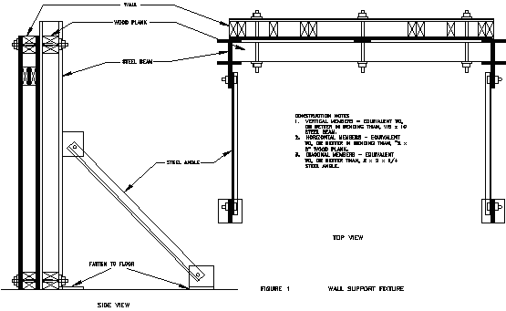
G. Component Test Fixture
1. The test fixture for doors, door jambs, hinges, and lock strikes as components shall consist of a vertical wall section constructed from 2 X 4 studs, with a rough entry door opening, and shall be covered with 1/2" exterior grade plywood sheathing on the exterior and 1/2" gypsum board on the interior. It shall be constructed as shown in Figure 2, and shall be secured to the wall support fixture at the sides and the top, and to the laboratory floor. For tests of doors, lock strikes, and hinges as components, the fixture wall section shall also include a door jamb.

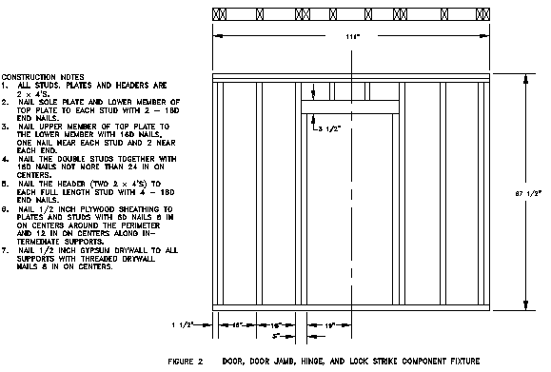
1.05 QUALITY ASSURANCE
A. Labeled doors and frames shall be provided for those openings requiring fire protection ratings as determined and scheduled by the Architect. Such doors and frames shall be constructed as tested and approved by Underwriters Laboratories or other recognized testing agency having a factory inspection service.
B. If any door or frame specified by the architect to be fire-rated cannot qualify for appropriate labeling because of its design, hardware or any other reason, the Architect shall be so advised before fabricating work on that item is started.
C. Doors and frames shall be constructed in conformance with the designs which satisfactorily meet the laboratory test requirements for commercial security as specified in this standard.
D. For special doors, suitable data in the form of laboratory test reports or certification shall be provided to substantiate performance relative to (acoustical properties) (radiation shielding) (pressure resistance) (others) when specified by the Architect.
Architect to indicate special performance features when such are required.
1.06 REFERENCES
A. ANSI A115.1 to ANSI A115.11, July 1971, Specifications for Door and Frame Preparation for Hardware
B. ANSI A156 Series for Hardware Standards
C. ASTM A366-72 (1979), Specification for Steel, Carbon, Cold-Rolled Sheet, Commercial Quality
D. ASTM A526-80, Specification for Steel Sheet, Zinc Coated (Galvanized) by the Hot-Dip Process Commercial Quality
E. ASTM A569-72 (1979), Specifications for Steel, Carbon (0.15 Maximum Percent), Hot-Rolled Steel and Strip, Commercial Quality
F. ASTM F476-84, Test Methods for Security of Swinging Door Assemblies
G. NAAMM Standard HMMA 861-86, Specifications for Commercial Hollow Metal Doors and Frames
H. NILECJ-STD-0306.00, May 1976, Physical Security of Door Assemblies and Components, Class IV
I. UL 437, Keylocks
J. UL 972, Burglary Resisting Glazing Materials
ANSI - American National Standards Institute, Inc.
1430 Broadway
New York, New York 10018
ASTM - American Society for Testing and Materials
1916 Race street
Philadelphia, Pennsylvania 19103
NAAMM - National Association of Architectural Metal Manufacturers
600 South Federal Street, Suite 400
Chicago, Illinois 60605
NILECJ - U.S. Department of Justice
National Institute of Justice
Washington, D.C. 20531
UL - Underwriters Laboratories, Inc.
333 Pfingsten Rd.
Northbrook, Illinois 60062
1.07 SUBMITTALS
A. Reports
Commercial security hollow metal manufacturers shall submit to the Architect, ten(10) days prior to bid date, an independent testing laboratory report certifying that the door and frame designs have been tested in accordance with 1.04 of this standard. Door and frame assemblies tested in accordance with NILECJ-STD-0306.00, or ASTM F476, and meeting the performance requirements for Class IV door assemblies and components, meet the specifications of this standard.
B. Shop Drawings
....(A)....copies of all necessary shop drawings shall be submitted to the Architect for his approval. These drawings shall fully describe and locate all items being furnished and shall include large scale details of principal construction features. Approved shop drawings shall constitute final contract requirements, and no work shall be fabricated until shop drawings for that work have been approved by the Architect.
Architect to indicate number of copies to be submitted.
C. Samples (if required)
1. A sample of a door, showing edge, top and/or bottom construction, insulation, hinge reinforcement and face stiffening.
2. A sample of frame, showing welded corner joint, welded hinge reinforcements, dust cover boxes and floor anchors.
3. All samples submitted shall be of the production type and shall represent in all respects the minimum quality of work to be furnished by the manufacturer. No work represented by the samples shall be fabricated until the samples are approved, and any downgrading of quality demonstrated by the samples may be cause for rejection of the work.
Architect to specify whether either or both the door and frame samples shall be submitted for his approval and also specify other samples which may be required.
PART 2 - PRODUCTS
2.01 HARDWARE LOCATIONS
The location of hardware on doors and frames shall be as follows:
Hinges: Top 5" from head of frame to top of hinge.
Bottom 10" from finished floor to bottom of hinge.
Intermediate centered between top and bottom hinges.
On Dutch Doors 5" from head of frame to top of hinge; 10" from finished floor to bottom of bottom hinge; 5" from split line to top and bottom respectively.
Unit and integral type
locks and latches 38" to centerline of knob (from finished floor)
Deadlocks 60" to centerline of cylinder
Panic hardware 38" to centerline of cross bar from
Door pulls 42" to center of grip finished
Push-pull bars 42" to centerline of bar floor*
Arm pulls 47" to centerline
Push plates 48" to centerline of plate
Roller latches 45" to centerline
*Finished floor is defined as the top surface of the floor, except when resilient tile or carpet is used, when it is the top of the concrete slab. Where the carpet is more than 1/2" thick, allow a 1/4" clearance.
Note to Architect: When hollow metal frames only are specified, for use with doors to be furnished by others, hardware preparation on the doors is normally governed by its location on the frames as stated above. If the doors are to be factory mortised, the door supplier is responsible for coordinating hardware locations; if they are to be mortised at the site, proper hardware location is the responsibility of the trade doing the work.
2.02 CLEARANCES AND TOLERANCES
A. Edge clearances shall be provided as follows:
Between doors and frames, at head jambs: 1/8"
At door sills where no threshold is used: 3/8" max.
At door sills where threshold is used: 3/4" max. above finished floor. See footnote p. 7.*
Between edges of pairs of doors: 1/8"
B. Manufacturing tolerances shall be maintained within the following limits:
1. Frames for single door or pair of doors:
Width, measured between rabbets at the head:
Nominal opening width + 1/16", -1/32"
Height (total length of jamb rabbet):
Nominal opening height + 3/64"
Cross sectional profile dimensions:
Face + 1/32"
Stop + 1/32"
Rabbet + 1/64"
Depth + 1/32"
Throat + 1/16". Frames overlapping walls have throat dimension 1/8" greater
than dimensioned wall thickness to accommodate irregularities in wall construction.
Refer to frame profile detail below:
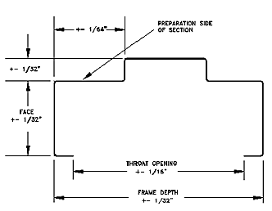

Hardware cutout dimensions:
Template dimensions +0.015", -0"
- Doors:
Width ± + 3/64"
Height + 3/64"
Thickness + 1/16"
Hardware cutout dimensions:
Template dimensions +0.015", - 0"
Hardware location: + 1/32"
2.03 HOLLOW METAL DOORS
A. Materials
1. Doors shall be made of commercial quality, level, cold rolled steel conforming to ASTM A366 or hot-rolled pickled and oiled steel conforming to ASTM A569 and free of scale, pitting or surface defects.
2. Interior Doors: Face sheets shall be not less than 14 gage.
3. Exterior Doors: Face sheets shall be not less than 14 gage and shall have a zinc coating applied by the hot-dip process conforming to ASTM A526 (A60 or G60) with a coating weight of not less than 0.60 ounces per square foot (0.30 ounces per square foot per side).
B. Design and Construction
1. All doors shall be of the types and sizes shown on approved shop drawings, and shall be fully welded seamless construction with no visible seams or joints on their faces or vertical edges. Minimum door thickness 1 3/4".
2. All doors shall be strong, rigid and neat in appearance, free from warpage or buckle. Corner bends shall be true and straight and of minimum radius for the gage of metal used.
3. Face sheets shall be stiffened by continuous vertical formed steel sections spanning the full thickness of the interior space between door faces. These stiffeners shall be not less than 18 gage, spaced not more than 6" apart and securely attached to face sheets by spot welds not more than 5" on center. Spaces between stiffeners shall be sound-deadened and insulated the full height of the door with an inorganic non-combustible batt-type material.
4. Door faces shall be joined at their vertical edges by a continuous weld extending the full height of the door. All such welds shall be ground, filled and dressed smooth to make them invisible and provide a smooth flush surface.
5. Top and bottom edges of all doors shall be closed with a continuous recessed steel channel not less than 12 gage, extending the full width of the door and spot welded to both faces. Exterior doors shall have an additional flush closing channel at their top edges and, where required for attachment of weatherstripping, a flush closure also at their bottom edges. Openings shall be provided in the bottom closure of exterior doors to permit the escape of entrapped moisture.
6. Jamb edges of all doors shall be reinforced with a continuous steel U channel not less than 12 gage extending full height of the door.
7. Edge profiles shall be provided on both vertical edges of doors as follows:
Single-acting swing doors - beveled 1/8" in 2".
Double-acting swing doors - rounded on 2 1/8" radius.
8. All hardware furnished by the hardware contractor for single-acting doors shall be designed for beveled edges as specified in 2.03.B.7.
9. Hardware Reinforcements:
a. Doors shall be mortised, reinforced, drilled and tapped at the factory for fully templated hardware only, in accord with the approved hardware schedule and templates provided by the hardware contractor. Where surfarce-mounted hardware is to be applied, doors shall have reinforcing plates only; all drilling and tapping shall be done by others.
b. Minimum gages for hardware reinforcing plates shall be as forces
Hinge and pivot reinforcements - 1/4" plate
Reinforcements for lock face, flush bolts, concealed holders, concealed or
surface-mounted closures - 12 gage
Reinforcements for all other surface mounted hardware - 12 gage
10. Glass Moldings and Stops (if applicable)
a. Where specified or scheduled, doors shall be provided with hollow metal moldings to secure glazing by others in accordance with glass opening sizes shown on approved shop drawings.
b. Fixed moldings shall be securely welded to the door on the security side.
c. All stops shall be not less than 16 gage steel, with (butt) (or) (mitered) corner joints, secured to the frame opening by non-temper "Spanner" type cadmium or zinc-coated countersunk screws. Snap-On attachments will not be permitted.
11. (If applicable) Louvers shall be of the welded blade type of construction (providing the free air area specified by the Architect). Louvers pierced into the face sheets will not be permitted. Provide stationary, sightproof louvers of manufacturer's design with 14 gage blades welded or tenoned to frame. In addition, louvers for exterior doors, where shown, shall have steel-framed screens secured to back of louvers. Wire cloth for screens shall be 1/4" square galvanized hardware cloth.
12. Labeled Doors: See 2.06
C. Finish: After fabrication, all tool marks and surface imperfections shall be dressed, filled and sanded as required to make all faces and vertical edges smooth, level and free of all irregularities. Doors shall then be chemically treated to insure maximum paint adhesion and shall be coated, on all exposed surfaces, with a rust-inhibitive primer which is fully cured before shipment.
D. Performance criteria: Doors shall meet the impact resistance performance specified in 1.04.D.
2.04 HOLLOW METAL PANELS
A. Hollow metal panels shall be made of the same materials and construction and finished In the same way as specified for hollow metal doors.
2.05 HOLLOW METAL FRAMES
A. Materials:

1. Interior Openings: Frames shall be either commercial grade cold-rolled steel conforming to ASTM A366 or commercial grade hot-rolled and pickled steel conforming to ASTM A569. Metal thickness shall be not less than 12 gage.

2. Exterior Openings: Frames shall be made of commercial grade cold-rolled steel conforming to ASTM A366 or hot-rolled, pickled and oiled steel conforming to ASTM A569, not less than 12 gage, and shall have a zinc coating applied by the hot-dip process conforming to ASTM A526 (A60 or G60) with a coating weight of not less than 0.60 ounces per square foot (0.30 ounces per square foot per side).
B. Design and Construction:

1. All frames shall be welded units with integral trim, of the sizes and shapes shown on approved shop drawings. Knocked-down frames will not be accepted.

2. All finished work shall be strong and rigid, neat in appearance, square, and free of defects, warp or buckle. Molded members shall be clean cut, straight and of uniform profile throughout their lengths.

3. Jamb depths, trim, profile and backbends shall be as scheduled by the Architect and shown on approved shop drawings.

4. Corner joints shall have all contact edges closed tight, with trim faces mitered and continuously welded, and stops (mitered) (or) (butted). The use of gussets will not be permitted.

5. Minimum depth of stops shall be 5/8". Cut off (sanitary or hospital type) stops, where scheduled, shall be capped at (45() (or) (90() at heights shown on approved shop drawings, and all jamb joints below cut-off steps shall be ground and filled smooth, making them imperceptible.

6. When shipping limitations so dictate, frames for large openings shall be fabricated in sections designated for splicing in the field by others.

7. Frames for multiple openings or special openings shall have mullion and/or rail members which are closed tubular shapes having no visible seams or joints. All joints between faces of abutting members shall be securely welded and finished smooth.

8. Hardware Reinforcements:
a. Frames shall be mortised, reinforced, drilled and tapped at the factory for fully templated and mortised hardware only, in accord with approved hardware schedule and templates provided by the hardware contractor. Where surface-mounted hardware is to be applied, frames shall have reinforcing plates only; all drilling and tapping shall be done by others.
b. Minimum thickness of hardware reinforcing plates shall be as follows:
Hinge and pivot reinforcements 1/4" plate full width of frame x 10"
Strike reinforcements 7 gage
Flush bolt reinforcements 7 gage
Closer reinforcements 7 gage
Reinforcements for:
Surface-mounted hardware 7 gage
Hold-open arms 7 gage
surface panic devices 7 gage

9. Floor Anchors:
a. Floor anchors shall be securely welded inside each jamb, with two holes provided at each jamb for floor anchorage.
b. Where so scheduled or specified, adjustable floor anchors, providing not less than 2" height adjustment, shall be provided.
c. Minimum thickness of floor anchors shall be 14 gage.

10. Jamb Anchors:
a. Frames for installation in masonry walls shall be provided with adjustable jamb anchors of the (T-strap) (or) (wire) type. Anchors shall not be less than 14 gage steel or 0.156" diameter steel wire. Stirrup straps shall be not less than 2" X 10" in size, corrugated and/or perforated. The number of anchors provided on each jamb shall be as follows:
Frames up to 7'6" height 3 anchors
Frames 7'6" to 8'0" height 4 anchors
Frames over 8'0" height 1 anchor for each 2"or fraction there of in height
b. Frames for installation in stud partitions shall be provided with steel anchors of suitable design, not less than 16 gage thickness securely welded inside each jamb as follows:
Frames up to 7'6" height 4 anchors
Frames 7'6" to 8'0" height 5 anchors
Frames over 8'0" height 5 anchors plus one additional for each 2" or fraction thereof over 8'0"
c. Frames to be anchored to previously placed concrete, masonry or structural steel shall be provided with anchors of suitable design as shown on approved shop drawings. Fasteners for each anchor shall be provided by others.

11. Frames for installation in masonry wall openings more than 4'0" in width shall have an angle or channel stiffener factory welded into the head. Such stiffeners shall be not less than 12 gage steel and not longer than the opening width, and shall not be used as lintels or load bearing members.

12. Dust cover boxes (or mortar guards) of not thinner than 26 gage steel shall be provided at all hardware mortises on frames to be set in masonry or plaster partitions.

13. All frames shall he provided with a steel spreader temporarily attached to the feet of both jambs to serve as a brace during shipping and handling.

14. (if applicable) Loose glazing stops shall be of cold rolled steel, not less than 16 gage thickness, butted at corner joints and secured to the frame on non-security side with special non-tamper screws that require special tools to remove screws.

15. Labeled Frames: See 2.06
C. Finish: After fabrication, all tools marks and surface imperfections shall be removed, and exposed faces of all welded joints shall be dressed smooth. Frames shall then be chemically treated to insure maximum paint adhesion and shall be coated on all accessible surfaces with a rust inhibitive primer which is fully cured before shipment.
D. Performance criteria: When Installed, frames shall meet the jamb/wall stiffness performance specified in 1.04.B.
2.06 LABELED DOORS AND FRAMES
A. Labeled doors and frames shall be provided for those openings requiring fire protectant ratings as determined and scheduled by the Architect. Such doors and frames shall be constructed as tested and approved by a nationally recognized testing agency having a factory inspection service.
B. If any door or frame specified by the Architect to be fire-rated cannot quality for appropriate labeling because of Its design, hardware or any other reason, the Architect shall be so advised before fabricating work on that item is started.
PART 3 -- EXECUTION
3.01 SITE STORAGE AND PROTECTION OF MATERIALS
A. The General Contractor shall see that any scratches or disfigurement caused in shipping or handling are promptly cleaned and touched up with a rust inhibitive primer, and that materials are properly stored on planks or dunnage, in a dry location, and covered to protect them from damage.
B. Doors shall have their wrappings or coverings removed upon delivery at the building site and shall be stored in a vertical position, in a dry location, spaced by blocking to permit air circulation between them.
3.02 INSTALLATION
It shall be the responsibility of the General Contractor to perform the following:
A. Prior to installation all frames must be checked and corrected for size, swing, squareness, alignment, twist and plumbness. Permissible installation tolerances shall not exceed the following:
Squareness + 1/16": measured on a line, 90 degrees from one jamb,the upper corner of the frame at the other jamb.
Alignment + 1/16": measured on jambs on a horizontal line parallel to the wall.
Twist + 1/16" measured at face corners of jambs on parallel lines perpendicular to the plane of the wall.
Plumbness + 1/16" measured on the jamb at the floor.
Details opposite illustrate methods of measuring above specified tolerances.
B. Proper door clearances must be maintained in accordance with 2.02 of these specifications, except for special conditions otherwise noted. Where necessary, metal hinge shims, furnished by the General Contractor, are acceptable to maintain clearances.
C. Hardware must be applied in accordance with hardware manufacturer's templates and instructions.
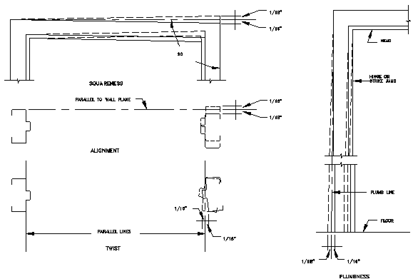

Note to Architect: Proper installation is essential to the proper performance of doors and frames. The requirements for proper installation are given in the preceding paragraphs. However, it is important to recognize that installation is not normally the responsibility of the hollow metal manufacturer. For this reason the requirements for installation of hollow metal doors and frames should ge in that section of the specifications where installation of work is specified.

