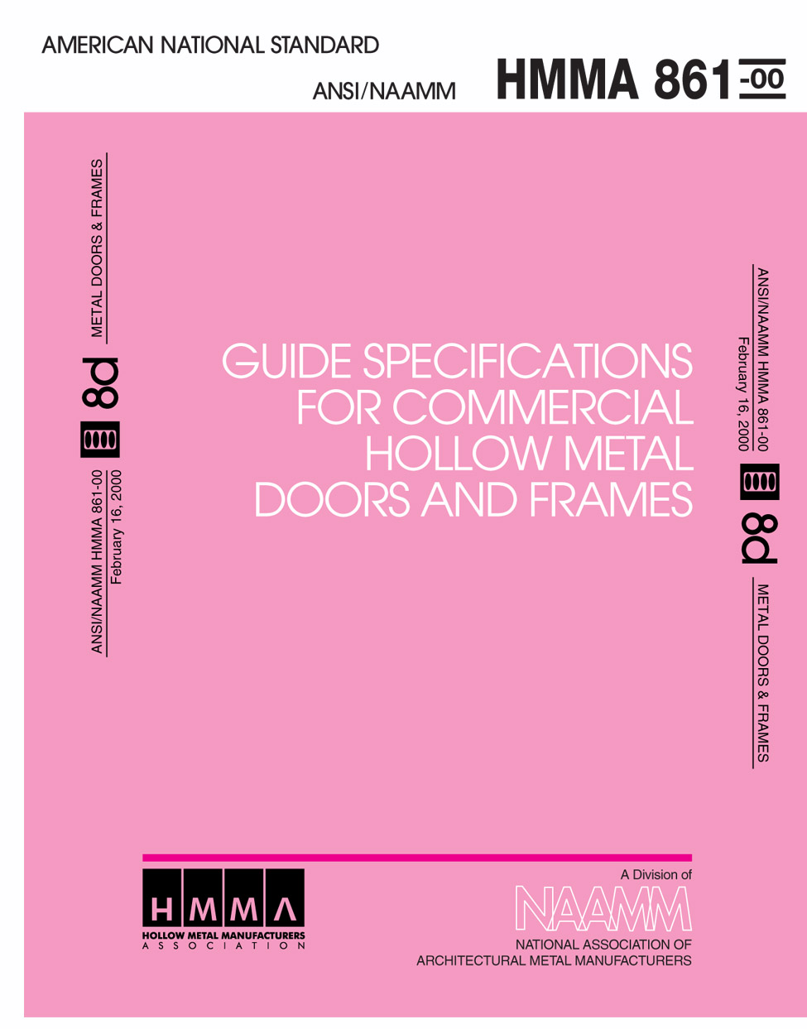

Approval of an American National Standard requires verification by ANSI that the requirements for due process, consensus, and other criteria for approval have been met by the standards developer.
Consensus is established when, in the judgment of the ANSI Board of Standards Review, substantial agreement has been reached by directly and materially affected interests. Substantial agreement means much more than a simple majority, but not necessarily unanimity. Consensus requires that all views and objections be considered, and that a concerted effort be made toward their resolution.
The use of American National Standards is completely voluntary; their existence does not in any respect preclude anyone, whether he has approved the standards or not, from manufacturing, marketing, purchasing, or using products, processes, or procedures not conforming to the standards.
The American National Standards Institute does not develop standards and will in no circumstances give an interpretation of any American National Standard. Moreover, no person shall have the right or authority to issue an interpretation of an American National Standard in the name of the American National Standards Institute. Requests for interpretation should be addressed to the sponsor whose name appears on the title page of this standard.
CAUTION NOTICE: This American National Standard may be revised or withdrawn at any time. The procedures of the American National Standards Institute require that action be taken periodically to reaffirm, revise, or withdraw this standard. Purchasers of American National Standards may receive current information on all standards by calling or writing the American National Standards Institute.
This manual was developed by representative members of the Hollow Metal Manufacturers Association Division (HMMA) of the National Association of Architectural Metal Manufacturers (NAAMM) to provide information and guidance on the selection of hardware for hollow metal doors and frames. This manual contains advisory information only and is published as a public service by NAAMM and its HMMA Division.

NAAMM AND ITS HMMA DIVISION DISCLAIM ALL LIABILITY OF ANY KIND FOR THE USE, APPLICATION OR ADAPTATION OF MATERIAL PUBLISHED IN THIS STANDARD.

Purchasers of NAAMM Standards may receive current information on all NAAMM Standards by calling or writing the National Association of Architectural Metal Manufacturers.

Copyright @1974, 1976, 1987, 1992, 2000
National Association of Architectural Metal Manufacturers
8 South Michigan Avenue Chicago, Illinois 60603
TABLE OF CONTENTS

Foreword 1
Part 1 – GENERAL
1.01 Summary 1
1.02 Products Provided Under this Section 1
1.03 Related Sections 1
1.04 References 2
1.05 Testing and Performance 3
1.06 Quality Assurance 4
1.07 Submittals 4
1.08 Warranty 4
Part 2 – PRODUCTS
2.01 Hollow Metal Doors 4
2.02 Hollow Metal Panels 6
2.03 Hollow Metal Frames 6
2.04 Clearances and Tolerances 9
2.05 Hardware Locations .10
2.06 Finish .11
Part 3 – EXECUTION
3.01 Site Storage and Protection of Materials .11
3.02 Installation .11
APPENDIX (Not part of the Standard)
Steel Tables .17

FOREWORD
These specifications have been prepared in accordance with the CSI recommended format with Part 1-General, Part 2-Product and Part 3-Execution. Explanatory notes or instructions are shown in italics. Guide specifications are intended to be used as the basis for developing job specifications and must be edited to fit specific job requirements. Inapplicable provisions should be deleted, appropriate selections should be made where there are choices, and provisions applicable to the job should be added where necessary. Optional items or requirements are shown in brackets. Notes and instructions to specifiers are given in italics directly following or at the start of the paragraphs to which they apply. Notes that contain permissive language are not considered part of the standard. Dates given with ASTM and other standards were current at the time this specification was published. When a more recent standard is available, the specifier should verify its applicability to this Guide prior to its inclusion.
Materials and fabrication methods are specified in detail in Part 2. Doors and frames made in accordance with these specifications have successfully met the testing and performance requirements of Paragraph 1.05. However, the materials and fabrication methods called for in these specifications, while providing a sound guide, are not meant to restrict the use of other materials and methods where it can be demonstrated through the specific testing procedures in Paragraph 1.06 that the construction can equal or exceed the performance levels specified in this paragraph. In order to ensure that a manufacturer's product meets the desired performance levels, the construction specifications must always include the testing and performance requirements of Paragraph 1.05 and the quality requirements of Paragraph 1.06.
For hollow metal doors and frames subject to less rigorous use than commercial and institutional applications, give consideration to NAAMM Standard HMMA 860, Guide Specifications for Hollow Metal Doors and Frames. If security is a factor, there are two hollow metal standards available - NAAMM Standard HMMA 862, Guide Specifications for Commercial Security Hollow Metal Doors and Frames and ANSI/NAAMM Standard HMMA 863, Guide Specifications for Detention Security Hollow Metal Doors and Frames. For acoustic applications, give consideration to ANSI/NAAMM Standard HMMA 865, Guide Specifications for Swinging Sound Control Hollow Metal Doors and Frames. NAAMM Standard HMMA 866, Guide Specifications for Stainless Steel Hollow Metal Doors and Frames, is appropriate for architectural uses and/or severely corrosive conditions.

CSI SECTION 08110
COMMERCIAL HOLLOW METAL DOORS AND FRAMES
PART 1 - GENERAL
1.01 SUMMARY
This Section includes commercial hollow metal products, including doors, panels, frames, and windows as shown in the contract documents.
1.02 PRODUCTS PROVIDED UNDER THIS SECTION
A. Commercial hollow metal doors, swinging type, including [glass moldings and stops] [louvers] [other] as shown in the contract documents.
B. Commercial hollow metal panels similar in construction to doors.
C. Commercial hollow metal frames, transom frames, sidelight and window assemblies, including [glass moldings and stops] [louvers] as shown in the contract documents.
1.03 RELATED SECTIONS
A. Section 08700 - Builders Hardware
B. Section 08700 - Gaskets and Weatherstrips
C. Section 08800 - Glass and Glazing Material
D. Section 09900 Painting
Note: This specification covers only those products listed in the foregoing paragraphs. Not included in this section are door hardware or rough hardware of any kind, weatherstripping, gaskets, items furnished by others, field painting, and protection at the building site of products furnished under this section.
1.04 REFERENCES
Note: The publications listed in this section form a part of this specification to the extent referenced. The publications are referenced in the text by basic designation only. When a more recent standard is available, the specifier shall verify its applicability to this Guide prior to its inclusion.
A. ANSI A250.4-1994, Test Procedure and Acceptance Criteria for Physical Endurance for Steel Doors and Hardware Reinforcings
B. ANSI/NAAMM HMMA 801-98, Glossary of Terms for Hollow Metal Doors and Frames
C. ANSI/NFPA 80 -1999, Standard for Fire Doors and Fire Windows
D. ANSI/NFPA 252-1995, Standard Methods of Fire Tests of Door Assemblies
E. ANSI/NFPA 257-1996, Standard Fire Test for Window and Glass Block Assemblies
F. ANSI/UL 9, Fire Test of Window Assemblies
G. ANSI/UL 10B, Fire Tests of Door Assemblies, 8th edition
H. ANSI/UL 10C, Standard for Positive Pressure Fire Tests of Door Assemblies
I. ASTM A 366/A 366M-97, Specification for Commercial Steel (CS) Sheet, Carbon, (0.15 Maximum Percent) Cold-Rolled
J. ASTM A 569/A 569M-98 Specification for Steel, Carbon, (0.15 Maximum, Percent), Hot-Rolled Sheet and Strip, Commercial
K. ASTM A 653/A 653M-97, Specification for Steel Sheet, Zinc Coated (Galvanized) or Zinc-Iron Alloy-Coated (Galvannealed) by the Hot-Dip Process (Commercial Steel)
L. ASTM B 117-97 Practice for Operating Salt Spray (Fog) Testing Apparatus
M. ASTM C 143/C143M-97 Test Method for Slump of Hydraulic Cement Concrete.
N. ASTM D 610-95 Standard Test Method for Evaluating Degree of Rusting on Painted Steel Surfaces
O. ASTM D 714-87 (1994) Standard Test Method for Evaluating Degree of Blistering of Paints
P. ASTM D 1735-97 Practice for Testing Water Resistance of Coating Using Water Fog Apparatus
Q. NAAMM HMMA 820-87, Hollow Metal Frames
R. NAAMM HMMA 830-87, Hardware Preparation and Locations for Hollow Metal Doors and Frames
S. NAAMM HMMA 831-97, Recommended Hardware Locations for Hollow Metal Doors and Frames
T. NAAMM HMMA 840-99, Installation and Storage of Hollow Metal Doors and Frames
U. NAAMM HMMA 850-00, Fire-Rated Hollow Metal Doors and Frames
V. 1997 UBC - Standard 7-2, Fire Tests of Door Assemblies
W. 1997 UBC - Standard 7-4, Fire Test of Window Assemblies
ANSI American National Standards Institute, Inc.
11 W. 42nd Street
New York, New York 10036
(212) 642-4900 www.ansi.org
ASTM American Society for Testing and Materials
100 Barr Harbor Drive
West Conshohocken, Pennsylvania 19428-2959
(610) 832-9585 www.astm.org
NAAMM National Association of Architectural Metal Manufacturers
8 S. Michigan Avenue
Chicago, Illinois 60603
(312) 332-0405 www.naamm.org
NFPA National Fire Protection Association
1 Batterymarch Park
P.O. Box 9101
Quincy, Massachusetts 02269
(617) 770-3000 www.nfpa.org
UL Underwriters Laboratories, Inc.
333 Pfingsten Road
Northbrook, Illinois 60062
(708) 272-8800 www.ul.com
UBC (ICBO) International Conference of Building Officials
5360 Workman Mill Road
Whittier, California 90601-2298
(562) 692-4226 www.icbo.org

1.05 TESTING AND PERFORMANCE
A. Performance Test for Steel Doors and Hardware Reinforcings (ANSI A250.4)

1. The test specimen shall be a 3'-0" x 7'-0" (914 mm x 2134 mm) nominal size 1- 3/4 in. (44 mm) door.

2. The specimen shall be tested in accordance with the ANSI A250.4 procedure and shall meet the Acceptance Criteria for the Level A doors.

3. Test reports shall include a description of the test specimen, procedures used in testing, and indicate compliance with the acceptance criteria of the test.
B. Labeled Fire-Rated Doors and Frames

1. Doors and frames shall be provided for those openings requiring fire protection ratings as determined and scheduled by the Architect. Such doors and frames shall be constructed as tested in accordance with [ANSI/NFPA 252, ANSI/UL-10B] [ANSI/UL-10C, UBC 7-2] and listed and/or classified for labeling by a recognized testing agency having a factory inspection service.

2. Window frames shall be provided for those openings requiring fire protection ratings as determined and scheduled by the Architect. Such frames shall be constructed as tested in accordance with [ANSI/NFPA 257, ANSI/UL 9] [UBC 7-4] and listed and/or classified for labeling by a recognized testing agency having a factory inspection service.

Note: UBC 7-2, ANSI/UL 10C, and UBC 7-4 are positive pressure test standards and should be included only for jurisdictions requiring such.
- If doors or frames specified by the Architect to be fire-rated cannot qualify for appropriate labeling because of design, hardware or other reasons, the Architect shall be so advised before fabricating work on that item is started.

Note: Refer to NAAMM HMMA 850, Fire-Rated Hollow Metal Doors and Frames.
1.06 QUALITY ASSURANCE
A. Manufacturer’s Qualifications

1. Manufacturer shall provide evidence of having personnel and plant equipment capable of fabricating hollow metal door and frame assemblies of the types specified.

2. Manufacturer shall provide evidence of having a quality control system in place.
B. Quality Criteria

1. Door and frame assemblies shall meet the requirements of Paragraph 1.05 of these specifications.

2. Fabrication methods and product quality shall meet the standards set by the Hollow Metal Manufacturers Association, HMMA, a Division of the National Association of Architectural Metal Manufacturers, NAAMM, as set forth in these specifications.
1.07 SUBMITTALS
A. Submittal Drawings

1. Show dimensioned door and frame elevations and sections.

2. Show listing of opening descriptions including locations, thicknesses, and anchors.

3. Show location and details of openings.
B. Samples (if required)

1. Door: corner section with hinge preparation showing top and internal construction.

2. Frame: corner section showing welding of head to jamb. Include hinge mortise, reinforcement and plaster guard in one rabbet and glazing stop applied as specified in the opposite rabbet. Glazing stop shall be applied to both head and jamb section to show corner joint.

3. Samples submitted shall be of the production type and shall represent in all respects the minimum quality of work to be furnished by the manufacturer. No work represented by the samples shall be fabricated until the samples are approved and any downgrading of quality demonstrated by comparison with the samples may be cause for rejection of the work.
1.08 WARRANTY
Hollow metal shall be warranted from defects in workmanship and quality for a period of one (1) year from date of shipment.
PART 2 - PRODUCTS
2.01 HOLLOW METAL DOORS
A. Materials

1. Doors shall be made of commercial quality, level, cold-rolled steel conforming to ASTM A 366/A 366M or hot-rolled, pickled and oiled steel conforming to ASTM A 569/A 569M. The steel shall be free of scale, pitting, coil breaks or other surface blemishes. It shall be free of buckles, waves or other defects caused by the use of improperly leveled sheets.

2. Interior doors: Face sheets shall be 0.042 in. (1.0 mm) minimum thickness.
Note: For interior areas subject to corrosive conditions it is recommended that zinc coated face sheets as specified in 2.01.A.3 be used.

3. Exterior Doors: Face sheets shall be 0.053 in. (1.3 mm) minimum thickness and shall have a zinc coating applied by the hot-dip process conforming to ASTM A 653/A 653M Coating Designation A60 (ZF180) or G60 (Z180).
B. Construction

1. Doors shall be the types, sizes, and construction in accordance with the contract documents, and shall meet the performance requirements of Section 1.05.

2. Door face sheets shall be joined at their vertical edges by a continuous weld extending the full height of the door with no visible seams on their faces or vertical edges.
Note: See “welded, continuously” in the Glossary of Terms for Hollow Metal Doors and Frames, ANSI/NAAMM HMMA 801.

3. Door thickness shall be 1 3/4 in. (44 mm) nominal. Doors shall be neat in appearance and free from warpage or buckle. Edge bends shall be true and straight and of minimum radius for the thickness of metal used.

4. The door shall be stiffened by continuous vertically formed steel sections which, upon assembly, shall span the full thickness of the interior space between door faces. These stiffeners shall be 0.026 in. (0.6 mm) minimum thickness, spaced so that the vertical interior webs shall be no more than 6 in. (152 mm) apart and securely fastened to both face sheets by spot welds spaced a maximum of 5 in. (127 mm) o. c. vertically. Spaces between stiffeners shall be filled with fiberglass or mineral rock wool batt-type material.

5. The top and bottom edges shall be closed with a continuous channel, not less than 0.053 in. (1.3 mm) thickness, spot welded to both face sheets.

6. Exterior doors shall be closed flush at the top edge. Where required for attachment for weatherstripping, a flush closure channel shall also be provided at the bottom edge. Openings shall be provided in the bottom closure channel of exterior doors to permit the escape of entrapped moisture.

7. Edge profiles shall be provided on both vertical edges of doors as follows:
• Single acting doors - beveled 1/8 in. (3 mm) in 2 in. (50.8 mm) profile
• Double acting doors - rounded on 2-1/8 in. (54 mm) radius

8. Hardware reinforcements:
a. Doors shall be mortised, reinforced, drilled and tapped at the factory for templated mortised hardware only, in accordance with the final approved hardware schedule and templates provided by the hardware supplier. Where surface mounted hardware, anchor hinges, thrust pivots, pivot reinforced hinges, or non-templated mortised hardware apply, doors shall be reinforced, with drilling and tapping done by others in the field.
b. Minimum thickness for hardware reinforcements shall be as follows:
• Full mortise hinges and pivots 0.167 in. (4.2 mm)
• Reinforcements for lock fronts, concealed holders,
or surface mounted closers 0.093 in. (2.3 mm)
• Internal reinforcements for other surface
applied hardware 0.067 in. (1.7 mm)

c. In cases where electrically operated hardware is required, and indicated on architectural door schedule, conduit, hardware enclosures and/or junction boxes within the door shall be provided. Access plates, where required, shall be the same thickness as the door face sheet and shall be fastened with a minimum of four (4) #8-32 machine screws or #6 sheet metal screws at a spacing not to exceed 12 in. (305 mm) o.c.

9. Glass moldings and stops:
a. Where specified, doors shall be provided with steel moldings to secure glazing by others in accordance with glass sizes and thicknesses shown on approved submittal drawings.
b. Fixed glass molding shall be welded to the secure side.
c. Removable glass stops shall be channel shaped not less than 0.032 in. (0.8 mm) thickness with tight fitting butt or mitered corner joints, and secured with #6 zinc coated countersunk sheet metal screws.
d. The metal surfaces to which glazing stops are secured and the inside of the glazing stops shall be chemically treated for maximum paint adhesion and painted with a rust inhibitive primer prior to installation in the door.

10. Louvers shall be of the welded inverted vee type, Y type, or face sheet pierced construction. The inverted vee and Y type vanes shall be not less than 0.042 in. (1.0 mm) thickness. Insect screens and/or bird screens shall be provided on louvered doors in exterior locations where shown on contract documents.
2.02 HOLLOW METAL PANELS
A. Hollow metal panels shall be made of the same materials and construction and finished in the same way as specified in Section 2.01 of this specification.
2.03 HOLLOW METAL FRAMES
Note: Provisions of Section 2.03 are applicable to frames, transom frames, sidelights, and window assemblies.
A. Materials

1. Frames shall be constructed of commercial quality, cold rolled steel conforming to ASTM A 366/A 366M or hot-rolled, pickled and oiled steel conforming to ASTM A 569/A 569M, the steel shall be free of scale, pitting, coilbreaks or other surface defects.

2. Interior openings: For door openings 4'-0" (1219 mm) or less in width and for window frames, steel shall be 0.053 in. (1.3 mm) minimum thickness. For door openings greater than 4'-0" (1219 mm) in width, steel shall be 0.067 in. (1.7 mm) minimum thickness.
Note: For interior areas subject to corrosive conditions it is recommended that zinc coated frames as specified in 2.03.A.3 be used.

3. Exterior openings: Openings shall have a zinc coating applied by the hot-dip process conforming to ASTM A653/A653M Coating Designation A60 (ZF180) or G60 (Z180). For door openings 4'-0" (1219 mm) or less in width and for window frames, steel shall be 0.053 in. (1.3 mm) minimum thickness. For door openings greater than 4'-0" (1219 mm) in width, steel shall be 0.067 in. (1.7 mm) minimum thickness.
B. Construction

1. Frames shall have integral stops and be welded units of the sizes and types shown on approved submittal drawings. Frames shall be constructed in accor-dance with these specifications and meet performance criteria specified in Section 1.05. Knock down frames are not acceptable.

2. Finished work shall be neat in appearance, square, and free of defects, warps and buckles. Pressed steel members shall be straight and of uniform profile throughout their lengths.

3. Jamb, header, mullion and sill profiles shall be in accordance with the frame schedule and as shown on the approved submittal drawings.

4. Corner joints shall have contact edges closed tight with faces mitered and stops either butted or mitered. Faces and soffits shall be continuously welded (see Figure 1) and the faces finished smooth. The use of gussets or splice plates as a substitute for welding shall not be acceptable.

5. Other face joints shall be continuously welded and smoothly finished.
Note: See NAAMM HMMA 820 “Hollow Metal Frames” page 6 for further details on frame welding.

6. Minimum depth of stops shall be 5/8 in. (15.8 mm). Cut-off stops, where shown, shall be capped at heights as shown on approved submittal drawings, and jamb joints below cut-off stops shall be welded, filled and ground smooth so that there are no visible seams.
Note: It is recommended that cut off stops not be used at exterior, lead lined, or gasketed openings.

7. When shipping limitations so dictate, frames for large openings shall be fabricated in sections designated for assembly in the field by others. Alignment plates or angles shall be installed at each joint. Such components shall be the same thickness as the frame. Field joints shall be made in accordance with approved submittal drawings and shall be field welded by others.

8. Hardware Reinforcements:
a. Frames shall be mortised, reinforced, drilled and tapped at the factory for templated mortised hardware only, in accordance with the final approved hardware schedule and templates provided by the hardware supplier. Where surface mounted hardware, anchor hinges, thrust pivots, pivot reinforced hinges, or non-templated mortised hardware apply, frames shall be reinforced, with drilling and tapping done by others in the field.
b. Minimum thickness of hardware reinforcing plates shall be as follows:
• Hinge and pivot reinforcement 0.167 in. x 1.25 in. x 10 in. length (4.2 mm x 31.7 mm x 254 mm)
• Strike reinforcements 0.093 in. (2.3 mm)
• Closer reinforcements 0.093 in. (2.3 mm)
• Flush bolt reinforcements 0.093 in. (2.3 mm)
• Reinforcements for surface applied hardware 0.093 in. (2.3 mm)
• Reinforcements for hold open arms 0.093 in. (2.3 mm)
• Reinforcements for surface panic devices 0.093 in. (2.3 mm)

9. Floor anchors:
a. Where applicable, floor anchors shall be provided with two holes for fasteners and shall be fastened inside jambs with at least four (4) spot welds per anchor.
b. Where so scheduled, adjustable floor anchors, providing no less than 2 in. (50.8 mm) height adjustment, shall be fastened in place with at least four (4) spot welds per anchor.
c. Thickness of floor anchors shall be a minimum of 0.067 in. (1.7 mm).

10. Jamb Anchors

a. Masonry Type

Frames for installation in masonry walls shall be provided with adjustable jamb anchors of the strap and stirrup or T-strap type not less than 0.053 in. (1.3 mm) thickness, or wire type not less than 0.156 in. (4 mm) in diameter. Straps shall be no less than 2 in. x 10 in. (50 mm x 254 mm) in size, corrugated and/or perforated. Anchors shall be placed not greater than 18 in. (457 mm) from top and bottom of openings. The minimum number of anchors spaced at maximum of 32 in. (813 mm) o.c. provided on each jamb based on frame opening height shall be as follows:
• up to 60 in. (1524 mm) 2 anchors
• greater than 60 in. (1524 mm) up to 90 in. (2286 mm) 3 anchors
• greater than 90 in. (2286 mm) up to 96 in. ( 2438mm) 4 anchors
• greater than 96 in. (2438 mm) 4 anchors plus 1 for each 24 in. (610 mm) or fraction thereof over 96 in. (2438 mm), spaced at 24 in. (610 mm) maximum between anchors

b. Dry Wall Type

Frames for installation in stud partitions shall be provided with steel an-chors of suitable design, not less than 0.042 in. (1.0 mm) thickness, securely welded inside each jamb. Anchors shall be placed not greater than 18 in. (457 mm) from top and bottom of openings. The minimum number of anchors spaced at maximum of 32 in. (813 mm) provided on each jamb based on frame opening height shall be as follows
• up to 60 in. (1524 mm) 3 anchors
• greater than 60 in. (1524 mm) up to 90 in. (2286 mm) 4 anchors
• greater than 90 in. (2286 mm) up to 96 in. ( 2438mm) 5 anchors
• greater than 96 in. (2438 mm) 5 anchors plus 1 for each 24 in. (610 mm) or fraction thereof over 96 in. (2438 mm), spaced at 24 in. (610 mm) maximum between anchors

c. Expansion Bolt Type

Frames for installation in existing masonry or concrete walls shall be prepared for expansion bolt type anchors. The preparation shall consist of a countersunk hole for a 3/8 in. (9.5 mm) diameter bolt and a spacer from the unexposed surface of the frame to the wall. The spacer shall be welded to the frame and spaced a maximum of 6 in. (152 mm) from the top and bottom of the door opening, with intermediate spacing at a maximum of 26 in. (660 mm) o.c. Fasteners for such anchors shall be provided by others.

d. Frames to be installed in pre-finished concrete, masonry or steel openings, shall be constructed and provided with anchoring systems of suitable design as shown on the approved submittal drawings. Fasteners for such anchors shall be provided by others.
Note: A pre-finished opening may be one that is constructed in the shop as part of another assembly or system (e.g., precast concrete panel) and which requires anchors similar in performance to those covered by 2.03 B. 10. a, b, and c.

11. Frames for installation in masonry wall openings more than 4'-0" (1219 mm) in width shall have an angle or channel stiffener factory welded into the head when the head is to be grouted. Such stiffeners shall be not less than 0.093 in. (2.3 mm) in thickness and not longer than the opening width, and shall not be used as lintels or load bearing members.

12. Plaster guards made from not less than 0.016 in. (0.4 mm) thick steel shall be attached at hardware mortises on frames to be set in masonry or concrete openings.

13. Frames shall be provided with a temporary steel spreader welded to the feet of the jambs to serve as bracing during shipping and handling and which shall not be used for installation.

14. Loose glazing stops
a. Removable glass channel stops shall be cold rolled steel, not less than 0.032 in. (0.8 mm), butted at corner joints and secured to the frame using cadmium or zinc plated #6 minimum countersunk sheet metal screws.
b. The frame underneath the glazing stops and the inside of the glazing stop shall be treated for maximum paint adhesion and painted with a rust inhibitive primer prior to installation in the frame.
2.04 CLEARANCES AND TOLERANCES
Note: The manufacturer of the doors and frames is responsible only for the manufacturing tolerances listed in 2.04 B. The final clearances and relationships between door and frame depend on the setting of the frame and the hanging and adjustment of the door and hardware. If everything is perfect in the setting of the frames and the manufacturing of the doors and frames, the clearances should be as shown in 2.04 A. However, if the frame is set to its maximum allowable tolerances, and doors and frames are manufactured to their maximum allowable tolerances, the clearances could be greater. See Notes in 3.02.
A. Edge clearances for swinging doors shall not exceed the following:

1. Between doors and frames at head and jambs 3/16 in. (4.7 mm)

2. Between edges of pairs of doors 3/16 in. (4.7 mm)

3. At door sills where a threshold is used 3/8 in. (9.5 mm) from bottom of door to top of threshold

4. At door sills where no threshold is used 3/4 in. (19.0 mm)

5. Between door bottom and nominal surface of floor
coverings at fire rated openings as provided in
ANSI/NFPA 80 1/2 in. (12.7 mm)
Note: Finished floor is defined as the top surface of the floor, except when resilient tile or carpet is used, when it is the top of the concrete slab.
B. Manufacturing tolerance shall be maintained within the following limits:

1. Frames for single door or pair of doors:

Width, measured between rabbets at the head: Nominal opening width

+ 1/16 in. (1.5 mm), - 1/32 in. (0.8 mm)

Height (total length of jamb rabbet): Nominal opening height ± 3/64 in. (1.2 mm)

Cross sectional profile dimensions (see Figure 2):

• Face ± 1/32 in. (0.8 mm)

• Stop ± 1/32 in. (0.8 mm)

• Rabbet ± 1/32 in. (0.8 mm)

• Depth ± 1/32 in. (0.8 mm)

• Throat ± 1/16 in. (1.5 mm). Frames overlapping walls to have throat dimension 1/8 in. (3.1 mm) greater than dimensioned wall thickness to accommodate irregularities in wall construction.

2. Doors

• Width ± 3/64 in. (1.2 mm)

• Height ± 3/64 in. (1.2 mm)

• Thickness ± 1/16 in. (1.5 mm)

3. Hardware

• Cutout dimensions template dimensions +0.015 in. (0.38 mm), - 0

• Location ± 1/32 in. (0.8 mm)
2.05 HARDWARE LOCATIONS
A. The location of hardware on doors and frames shall be as listed below. Note that all dimensions except the hinge locations are referenced from the finished floor as defined in Paragraph 2.04A.
Note to Architect: When hollow metal frames only are specified for use with doors to be furnished by others, hardware preparation on the doors is normally governed by its location on the frames as stated in 2.05 B. If the doors are to be factory mortised, the door supplier is responsible for coordinating hardware locations; if they are mortised at the job site, proper hardware location is the responsibility of the trade doing the work.
B. Hinges:

Top 5 in. (127 mm) from frame head to top of hinge

Bottom 10 in. (254 mm) from finished floor to bottom of hinge

Intermediate centered between top and bottom hinges

On Dutch Doors 5 in. (127 mm) from head of frame to top of hinge; 10 in. (254 mm) from finished floor to bottom of bottom hinge; 5 in. (127 mm) from split line to top and bottom respectively of lower and upper intermediate hinges.

Unit and integral type
locks and latches 8 in. (965 mm) to centerline of knob

Deadlocks 46 in. (1168 mm) to centerline of cylinder

Panic hardware 38 in. (965 mm) to centerline of cross bar or as shown on hrdware template

Door pulls 42 in. (1066 mm) to center of grip

Push/pull bars 42 in. (1066 mm) to centerline of bar

Arm pulls 46 in. (1168 mm) to centerline

Push plates 46 in. (1168 mm) to centerline of plate

Roller latches 45 in. (1143 mm) to centerline of plate
Note: See NAAMM / HMMA 830 and 831 for additional information.

2.06 FINISH
After fabrication, tool marks and surface imperfections shall be filled and sanded as required to make face sheets, vertical edges and weld joints free from irregularities. After appropriate metal preparation, exposed surfaces of doors and frames shall receive a rust inhibitive primer which meets or exceeds ASTM B 117 Salt Spray for 150 hours with a rust grade of not less than 6 as defined in ASTM D 610, and ASTM D 1735 Water Fog Test for organic coatings for 200 hours with any quantity of #8 blisters but no more than “few” #6 blisters as illustrated in ASTM D 714.
PART 3 -- EXECUTION
3.01 SITE STORAGE AND PROTECTION OF MATERIALS
A. The contractor responsible for installation shall remove wraps or covers from doors and frames upon delivery at the building site. The contractor responsible for installation shall see that scratches or disfigurement caused in shipping or handling are promptly cleaned and touched up with a rust inhibitive primer.
B. The contractor responsible for installation shall see that materials are properly stored on planks or dunnage in a dry location. Doors shall be stored in a vertical position and spaced by blocking. Figure 3 illustrates recommended storage positioning. Materials shall be covered to protect them from damage but in such a manner as to permit air circulation.
3.02 INSTALLATION
Note to Architect: Correct installation is essential to the proper performance of doors and frames. The require-ments for proper installation are given in the following paragraphs. However it is important to recognize that installation is not the responsibility of the hollow metal manufacturer. For this reason the requirements for installation of hollow metal doors and frames should be in that section of the specifications where installation work is specified. For additional information regarding installation see NAAMM HMMA 840 “Installation and Storage of Hollow Metal Doors and Frames”.

The Installer shall perform the following:
A. Prior to installation, frames shall be checked and corrected for size, swing, squareness, alignment, twist and plumbness. Permissible installation tolerances shall not exceed the following:

• Squareness + 1/16 in. (1.5 mm) measured on a line, 90 degrees from one jamb, at the upper corner of the frame at the other jamb.

• Alignment + 1/16 in. (1.5 mm) measured on jambs on a horizontal line parallel to the plane of the wall.

• Twist + 1/16 in. (1.5 mm) measured at face corners of jambs on parallel lines perpendicular to the plane of the wall.

• Plumbness + 1/16 in. (1.5 mm) measured on the jamb at the floor.
Note: The above tolerances provide a reasonable guideline for proper installation of hollow metal frames. However, it should be noted that the cumulative affect of the tolerances at their maximum levels will result in sufficient misalignment to prevent the door from functioning properly. Installers should be careful not to create a tolerance buildup. Tolerance buildup occurs when more than one dimension is at or near its maximum tolerance.

The details in Figure 4 illustrate methods of measuring the above specified tolerances.
B. Plaster guards and junction boxes are intended to protect hardware mortises and tapped mounting holes from masonry grout of 4 in. (101 mm) maximum slump consistency which is hand troweled in place. If a lighter consistency grout (greater than 4 in. (101 mm) slump when tested in accordance with ASTM C 143/C 143M) is to be used, special precautions must be taken in the field by the installer to protect the aforementioned.
C. Proper door clearances must be maintained in accordance with 2.04 of these specifications, except for special conditions otherwise noted. Metal hinge shims, furnished by installer, are permitted to maintain clearances.
D. Hardware must be applied in accordance with hardware manufacturer's templates and instructions.
E. Hollow metal surfaces shall be kept free of grout, tar, and/or other bonding materials or sealers. Grout, tar, and/or other bonding materials or sealers shall be promptly cleaned off of frames or doors.
F. Primed or painted surfaces which have been scratched or otherwise marred during installation (including field welding) and/or cleaning shall promptly be finished smooth, cleaned, treated for maximum paint adhesion and touched up with a rust inhibitive primer.
G. Labeled fire doors and frames shall be installed in accordance with NFPA 80 or in accordance with local authority having jurisdiction.

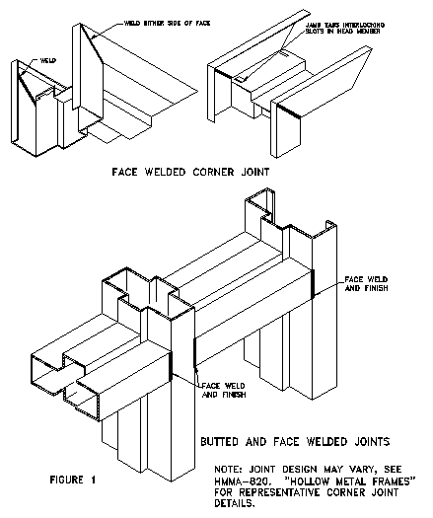

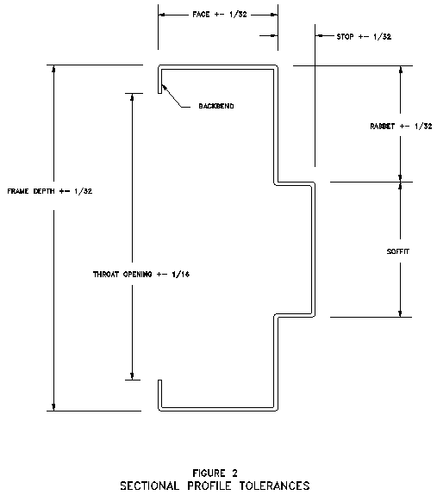

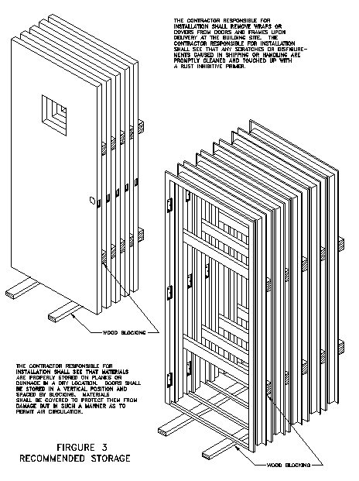
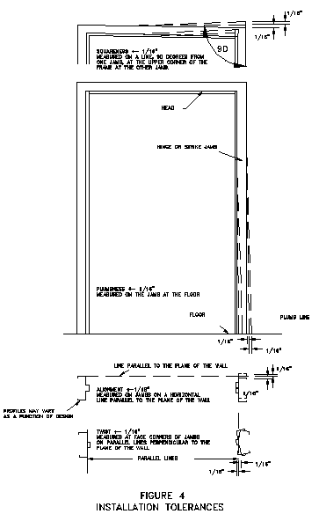
APPENDIX
(Not part of the Standard)
STEEL TABLES

Prior to 1970, sheet steel was referred to by gage. ASTM and ANSI currently do not list gage numbers in their standards. Like many generic terms, gage (or guage) is ingrained in many vocabularies and is misunderstood as a term for thickness. NAAMM is publishing this minimum thickness table to be used instead of discontinued gage numbers.
The values shown were taken from the Underwriters Laboratories, Inc. publication for gage number and equivalent thickness.
MINIMUM THICKNESS |  |  |  | CONVERSION
Uncoated Steel Sheet |  |  |  | Fraction | Decimal | Mm
Gage | Decimal | mm |  |  | 1.000 | 25.4
4 | 0.214 | 5.4 |  | 15/16 | 0.937 | 23.8
5 | 0.199 | 5.0 |  | 7/8 | 0.875 | 22.2
6 | 0.184 | 4.6 |  | 13/16 | 0.812 | 20.6
7 | 0.167 | 4.2 |  | 3/4 | 0.750 | 19.0
8 | 0.152 | 3.8 |  | 11/16 | 0.687 | 17.4
10 | 0.123 | 3.1 |  | 5/8 | 0.625 | 15.8
12 | 0.093 | 2.3 |  | 9/16 | 0.562 | 14.2
14 | 0.067 | 1.7 |  | 1/2 | 0.500 | 12.7
16 | 0.053 | 1.3 |  | 7/16 | 0.437 | 11.1
18 | 0.042 | 1.0 |  | 3/8 | 0.375 | 9.5
20 | 0.032 | 0.8 |  | 5/16 | 0.312 | 7.9
22 | 0.026 | 0.6 |  | 1/4 | 0.250 | 6.3
24 | 0.02 | 0.5 |  | 3/16 | 0.187 | 4.7
26 | 0.016 | 0.4 |  | 1/8 | 0.125 | 3.1
28 | 0.013 | 0.3 |  | 1/16 | 0.062 | 1.5

DISCLAIMER
This sheet was developed by representative members of the Hollow Metal Manufacturers Association Division (HMMA) of the National Association of Architectural Metal Manufacturers (NAAMM) to provide their opinion and guidance on minimum thickness and metric equivalents used for hollow metal doors and frames. This sheet contains advisory information only and is published as a public service by the HMMA Division. NAAMM and its HMMA DIVISION DISCLAIM ALL LIABILITY OF ANY KIND FOR THE USE, APPLICATION OR ADAPTATION OF MATERIAL SHOWN ON THIS SHEET.
HMMA Hollow Metal Manufacturers Division of the
National Association of Architectural Metal Manufacturers NAAMM

