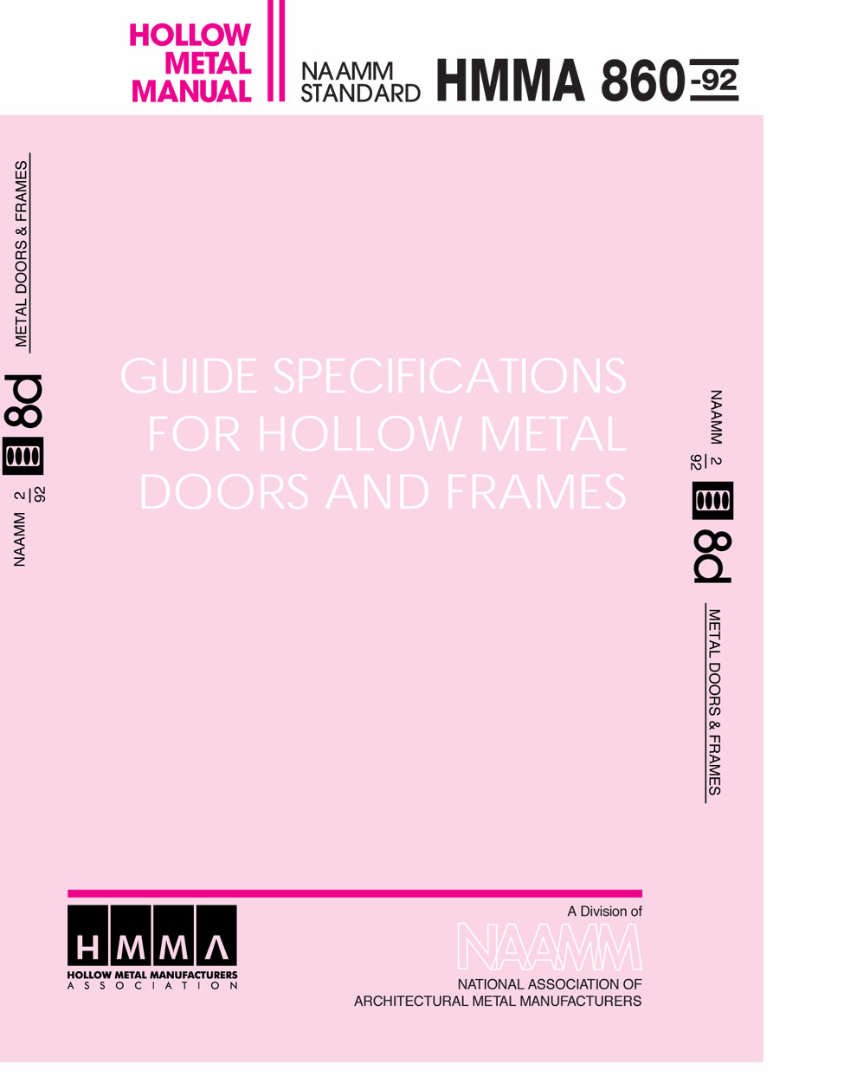

FOREWORD
These specifications have been prepared in accordance with the CSI recommended format with Part 1-General, Part 2-Product and Part 3-Execution. Explanatory notes or instructions are shown in italics. Guide specifications are intended to be used as the basis for developing job specifications and must be edited to fit specific job requirements. Inapplicable provisions should be deleted, appropriate selections should be made where there are choices, and provisions applicable to the job should be added where necessary. Optional items or requirements are shown in brackets. Notes and instructions to specifiers are given in italics directly following the paragraphs to which they apply. Dates given with ASTM and other standards were current at the time this specification was published. Specifier should use the latest dates when preparing job specifications.
Materials and fabrication methods are specified in detail in Part 2. Doors and frames made in accordance with these specifications have successfully met the testing and performance requirements of Paragraph 1.06. However, the materials and fabrication methods called for in these specifications, while providing a sound guide, are not meant to restrict the use of other materials and methods where it can be demonstrated through the specific testing procedures in Paragraph 1.06 that the construction can equal or exceed the performance levels specified in this paragraph. In order to ensure that a manufacturer’s product meets the desired performance levels, the construction specifications must always include the testing and performance requirements of Paragraph 1.06 and the quality requirements of Paragraph 1.07.
These guide specifications are limited to applications where traffic is relatively light and hard usage is not anticipated. For doors that do not fall into this category it is strongly recommended that NAAMM Standard HMMA 861, Guide Specifications for Commercial Hollow Metal Doors and Frames be used. If security is a factor there are two hollow metal standards available, NAAMM Standard HMMA 862, Guide Specifications for Commercial Security Hollow Metal Doors and Frames and NAAMM Standard HMMA 863, Guide Specifications for Detention Security Hollow Metal Doors and Frames. For acoustic applications consideration may be given NAAMM Standard HMMA 865, Guide Specification for Swinging Steel Sound Control Doors and Frames.

CSI BROADSCOPE SECTION 08110
HOLLOW METAL DOORS AND FRAMES
PART 1 - GENERAL
1.01 SUMMARY
This Section includes hollow metal products as specified and as shown in the contact drawings.
1.02 PRODUCTS FURNISHED BUT NOT INSTALLED UNDER THIS SECTION
A. Hollow Metal Doors, Swinging Type, [with 3 hour, 1 ½ hour, ¾ hour, 1/3 hour fire rating]
B. Doors shall include [glass moldings and stops] [louvers or louver inserts] [other] as shown in the schedule on the contract drawings and specified herein.
C. Hollow Metal Frames, Swinging Type, [with 3 hour, 1 ½ hour, ¾ hour, 1/3 hour fire rating]
D. Frames shall include [glass moldings and stops] [louvers or louvers inserts] [other] as shown in the schedule on the contract drawings specified herein.
E. Hollow Metal Panels. [with 3 hour, 1 ½ hour, ¾ hour, 1/3 hour fire rating] similar in construction to doors.
F. Hollow Metal Partition Ends, Fillers and Closures.
G. Hollow Metal Window Stools and Surrounds.
H. Hollow Metal Convector Enclosures.
I. Hollow Metal Venetian Blinds and Drapery Pockets.
J. Pass Windows of Hollow Metal Construction.
K. Hollow Metal Corner Guards.
L. Hollow Metal Expansion Joint Covers.
M. Hollow Metal Louvers.
The foregoing list is illustrative of items which may be included. Items may be deleted or added. However, specifier should list only those items required.
1.03 RELATED PRODUCTS FURNISHED BY OTHERS BUT NOT SPECIFIED IN THIS SECTION
A. Builders Hardware
B. Glass and Glazing Material
C. Gaskets and Weather-strips
This specification covers only those products listed in the foregoing paragraphs. Not included in this section are installation of doors, frames, panels, door hardware or rough hardware of any kind, weather-stripping, gaskets, items furnished by others, field painting, field splicing of oversized units, and protection at the building site of products furnished under this section.
1.04 RELATED SECTIONS
A. Section 08700 - Builders Hardware: Item(s)
B. Section 08800 - Glass and Glazing: Item(s)
C. Section 09900 - Field Painting: Item(s)
1.05 REFERENCES
The publications listed in this section form a part of this specification to the extent referenced. The publications are referenced in the text by basic designation only. Specifier should call for the most recently published standards when preparing specifications.
A. ANSI A151.1-1980 Test Procedure and Acceptance Criteria for Physical Endurance for Steel Doors and Hardware Reinforcings.
B. ASTM A 366-85, Specification for Steel, Carbon, Cold-Rolled Sheet, Commercial Quality.
C. ASTM A 526/A526M-85, Specification for Steel Sheet, Zinc Coated (Galvanized) by the Hot-Dip Process, Commercial Quality.
D. ASTM A 569-85, Specification for Steel, Carbon, (0.15 Maximum, Percent), Hot-Rolled Sheet and Strip, Commercial Quality.
E. ASTM B117-85 Method of Salt Spray (Fog) Testing.
F. ASTM D1735-87 Practice for Testing Water Resistance of Coating Using Water Fog Apparatus.
G. ASTM E152-81a Method for Fire Test of Door Assemblies.
H. NAAMM Hollow Metal Manual.
I. NFPA 80, Fire Doors and Windows.
J. U.L. 10B, Fire Tests of Door Assemblies, 7th Edition.
K. Manufacturer’s Standard Gage and Galvanized Sheet Gage.

ANSI American National Standards Institute, Inc.
1430 Broadway
New York, NY 10018

ASTM American Society for Testing and Materials
1916 Race Street
Philadelphia, PA 19103

UL Underwriters Laboratory
333 Pfingsten Road
Northbrook, IL 60062
1.06 TESTING AND PERFORMANCE
A. Performance Test for Steel Doors and Hardware Reinforcings (ANSI A151.1)

1. The test specimen shall be a 3’-0” x 7’-0” normal size 1 ¾” door.

2. The specimen shall be tested in accordance with the ANSI A151.1 procedure for the level A doors (1,000,000 cycles).

3. The specimen shall be tested in accordance with the ANSI A151.1 procedure for twist test which requires a maximum pressure of 300 lbs.
1.07 QUALITY
A. Manufacturer’s Qualifications

1. Manufacturer shall provide evidence of having personnel and plant equipment capable of fabricating hollow metal door and frame assemblies of the type specified herein.
B. Quality Criteria

1. All door and frame assemblies shall meet the requirements of Paragraph 1.06 of these specifications.

2. Fire labeled doors and frames shall be provided for those openings requiring fire protection ratings as determined and scheduled by the Architect. Such doors and frames shall be constructed as tested in accordance with UL-10b (ASTM E152) and approved by Underwriters Laboratories or other recognized testing agency having a factory inspection service.

3. If any door or frame specified to be fire rated cannot qualify for appropriate labeling because of its design, hardware or any other reason, the Architect shall be so advised before fabricating work on that item is started.

4. Fabrication methods and product quality shall meet the standards set by the Hollow Metal Manufacturers Associations, HMMA, a Division of the National Association of Architectural Manufacturers, NAAMM, as set forth in these specifications.
Refer to NAAMM ‘s Hollow Metal Manual and Fire Rated Hollow Metal Doors and Frames.
1.08 SUBMITTALS
A. Submittal Drawings

1. Show door and frame elevations and sections.

2. Show listing of opening descriptions including locations, gages and anchors.

3. Show location and details or all openings.
B. Samples (if required)

1. Door: 1’0” X 1’0” corner section with hinge preparation showing top and internal construction.

2. Frame: 1’0” X 1’0” corner section showing welding joint [knock down joint] of head to jamb. Include hinge reinforcement and plaster guard in one rabbet and glazing stop applied as specified in the opposite rabbet. Glazing stop must be applied to both head and jamb section to show corner joint.

3. All samples submitted shall be of the production type and shall represent in all respects the minimum quality of work to be furnished by the manufacturer. No work represented by the samples shall be fabricated until the samples are approved and any downgrading of quality demonstrated by the samples may be the cause for the rejection of the work.
1.09 WARRANTY
All hollow metal work shall be warranted from defects in workmanship and quality for a period of one (1) year from shipment.
PART 2 - PRODUCTS
2.01 HOLLOW METAL DOORS
A. Materials:

1. Doors shall be made of commercial quality, level, cold rolled steel conforming to ASTM A 366 or hot-rolled, pickled and oiled steel conforming to ASTM A 569 and free of scale, pitting or surface defects.

2. Interior Doors: Face sheets shall be not less then 20 gage.
Note: For interior doors subject to corrosive conditions it is recommended that Zinc coated sheets as specified in 2.01.A.3 be used.

3. Exterior Doors: Face sheets shall be not less than 18 gage and shall have zinc coating applied by the hot-dip process conforming to ASTM A526 (A60 or G60) with a coating weight of not less than 0.60 ounces per square foot (0.30 ounces per square foot per side).
B. Construction:

1. All doors shall be of the types and sizes shown on approved submittal drawings and shall as be constructed in accordance with the specifications and meet the performance requirements of Paragraph 1.06.

2. Door face sheets shall be joined at their vertical edges with no visible seems on their faces. Minimum door thickness shall be 1 ¾”.

3. Face sheets shall be stiffened by continuous vertical formed steel sections which, upon assembly span the full thickness of the interior space between the door faces. These stiffeners shall be not less than 22 gage, spaced so that the vertical interior webs shall be no more than 6” apart and securely fastened to both face sheets by spot welds spaced at a maximum of 5” o.c. vertically. Spaces between stiffeners shall be filled with fiberglass or mineral rockwool batt-type material.

4. Door edges to be constructed in one of the following methods:
a. Door faces shall be joined together at their vertical edges by a continuous weld extending the full height of the door. All such welds to be ground, filled and dressed smooth to make them invisible and provide a smooth flush surface.
b. Door edges shall be joined by an interlocking seam the full height of the door (lock seam) with at least 4 thicknesses of metal. Edge seam shall be welded at top and bottom of door and may also be tack welded above and below each hardware cutout. There shall be a vertical visible seem at both edges of door.
c. Door edges shall be joined by projection welding no more than 3” on center extending the full height of the door. There shall be a vertical visible seam at both edges of the door [visible seam shall be filled and finished smooth]
d. Door edges shall be joined by tack welds no more than 6” on center extending the full height of the door. The tack welds shall be ground, filled and dressed smooth to make them invisible and provide a smooth flush surface.

5. Top and bottom edges of all doors shall be closed with continuous steel channels not less than 16 gage, spot welded to both faces.

6 Exterior doors shall have an additional flush closing channel at their top edges and, where required for attachment of weather stripping, a flush closure also at their bottom edges. Openings shall be provided in the bottom closure of exterior doors to permit the escape of entrapped moisture.

7. Edge profiles shall be provided on both vertical edges of doors as follows:
• Single-acting swing doors - beveled 1/8” in 2”.
• Double-acting swing doors - rounded on 2-1/8” radius.

8. All hardware furnished by the hardware contractor for single-aching doors shall be designed for beveled edges as specified herein.

9. Hardware reinforcements:
a. Doors shall be mortised, reinforced, and tapped at the factory for fully templated mortise hardware only, in accordance with the approved hardware schedule and templates provided by the hardware supplier. Where surfacemounted or non-templated hardware is to be applied, doors shall have reinforcing plates only; all drilling and tapping shall be done by others.
b. Minimum gages for hardware reinforcing plates shall be as follows:
• Full mortise hinges & pivots 7 gage.
• Replacements for lock face, flush bolts 14 gage.
• Reinforcements for all other surface-mounted hardware 16 gage.

10. (If applicable) Glass moldings and stops.
a. Where specified or scheduled, doors shall be provided with hollow metal moldings to secure glazing by others in accordance with glass opening sizes shown on approved shop drawings.
b. Fixed moldings shall be securely welded to the door on the security side.
c. Loose stops shall be not less than 20 gage, with (butt) (or) (mitered) corner joints, [secured to the frame opening be cadmium - or zinc-coated counter-sunk screws].
d. Snap on moldings shall be designed with a non-removable stop on the security side after glass installation.

11. (If applicable) Louvers shall be of the welded blade type of construction. Louver inserts may be provided.

12. Finish: After fabrication, all tool marks and surface blemishes shall be filled and sanded as required to make both faces and both vertical edges smooth and free from irregularities. After appropriate preparation, all exposed surfaces shall receive a rust inhibitive primer which meets or exceeds ASTM D1735 water fog test for organic coatings for 200 hours, and which is fully cured prior to shipment.
2.02 HOLLOW METAL PANELS
A. Hollow metal panels shall be made of the same materials and construction and finished in the same way as specified in Section 2.01 of this specification.
2.03 HOLLOW METAL FRAMES
A. Materials

1. Interior Openings: Frames shall be either commercial grade cold-rolled steel conforming to ASTM A366 or commercial grade hot-rolled and pickled steel conforming to ASTM A 569. Metal thickness shall be not less than 16 gage for frames that receive hollow metal doors [18 gage for frames that receive hollow core wood doors.]
Note: For interior areas subject to corrosive conditions it is recommended that zinc coated frames as specified in 2.03.A.2 be used.

2. Exterior openings: Frames shall be made of commercial grade cold-rolled steel conforming to ASTM A 569 or hot-rolled, pickled and oiled steel conforming to ASTM A 569 not less than 16 gage, and shall have a zinc coating supplied by the hot-dip process conforming to ASTM A 526 (A60 or G60) with a coating weight of not less than 0.60 ounces par square foot (0.30 ounces per square foot per side).
B. Design and Construction

1. All frames shall be [welded] [knocked down] [slip on] units with integral trim, of the sizes and shapes shown on approved shop drawings.

2. All finished work shall be strong and rigid, neat in appearance, square, true and free of defects, warp or buckle. Molded members shall be clean cut, straight and of uniform profile through their lengths.

3. Jamb, header, mullion and sill profiles shall be in accordance with the frame schedule and as shown on the approved submittal drawings.

4. Corner joints at welded corners shall have all contact edges closed tight, with trim faces mitered and continuously welded, and stops mitered or butted (See Figure 1.)

5. At drywall partitions, knocked down frames may be furnished. Knocked down frames shall be the pressure fit type that are installed after the partition is in place.
Frames are to be anchored at the bottom of each jamb. Additional pressure fit type anchors are to be furnished at the mitered corners.
Option: Frames that receive 1-3/8” hollow core wood doors may be furnished with:
a. One (1) pair of 3-1/2” weld-on hinges. Frame leaf to be welded to frame and door leaf and pin shipped loose for installation on the wood doors by others.
b. Or mortised and reinforced for hinges furnished by others.

6. Minimum depth of stop shall be 5/8”. Cut-off stops, where shown, shall be capped at 45 (or 90), at heights as shown on the approved submittal drawings, [and jamb joints below cut-off stops shall be welded, finished smooth so that there are no visible seams].

7. Frames for multiple or special openings shall have mullion and/or rail members which are closed tubular shapes having no visible seams or joints. All joints between faces of abutting members shall be securely welded and finished smooth. (See Figure 1.)

8. When stripping limitations so dictate, frames for large openings shall be fabricated in sections designed for assembly in the field by others. Alignment plates or angles shall be installed at each joint. Such components shall be the same gage thickness as the frame. Field joints shall be made in accordance with approved submittal drawings and shall be welded by others.

9. Hardware reinforcements:
a. Frames shall be mortised, reinforced, drilled and tapped at the factory for fully templated mortised hardware only, in accordance with approved hardware schedule and templates provided by the hardware contractor. Where surface mounted hardware is to be applied, frames shall have reinforcing plates only; all drilling and tapping shall be done by others.
b. Minimum thickness of hardware reinforcing plates shall by as follows:
• Hinge 7 gage X 1-1/4” X 10”
minimum size.
• Strike reinforcements 12 gage or a 16 gage.
• Flush bolt reinforcements 12 gage.
• Closer reinforcements 12 gage.
• Reinforcements for surface mounted hardware 12 gage.

10. Floor anchors:
a. Floor anchors shall be securely welded inside each jamb for floor anchorage.
b. Minimum thickness of floor anchors shall be 18 gage.
c. Floor anchors may be omitted at frames designed for existing wall conditions. An additional frame anchor shall be provided in lieu of a floor anchor.

11. Jamb Anchors:
a. Frames for installation in masonry walls shall be provided with adjustable jamb anchors of the (T-strap) (or) (stirrup) (or) (wire) type. Anchors shall be not less than 16 gage steel or 0.156” diameter steel wire. Stirrup straps shall be not less than 2” X 10” in size, corrugated and/or perforated. The number of anchors provided on each jamb shall be as follows:
• Frames up to 60” height 2 anchors.
• Frames greater than 60” up to 90” 3 anchors.
• Frames greater than 90” up to 96” 4 anchors.
• Frames greater than 96” 4 anchors plus one for
each 24” or fraction thereof over 96”, spaced at 24”maximum between anchors.
b. Welded frames for installation in stud partitions shall be provided with steel anchors of suitable design, not less than 18 gage thickness, secured inside each jamb as follows:
• Frames up to 60” height 2 anchors.
• Frames greater than 60” up to 90” 4 anchors.
• Frames greater than 90” up to 96” 5 anchors.
• Frames greater than 96” 5 anchors plus one for
each 24” or fraction thereof over 96” spaced at 24” maximum between anchors.
c. Frames to be anchored to previously placed concrete, masonry or structural steel shall be provided with anchors of suitable design and quantity as shown on approved shop drawings. Fasteners for such anchors shall be provided by others.
d. Slip on frames shall be provided with a single adjustable tension anchor in each jamb and provision for secure attachment of each jamb base to stud runners.

12. Plaster guards made from no less than 26 gage steel shall be welded in place at all hardware mortises on frames to be set in masonry or concrete openings.

13. All welded frames shall be provided with a temporary steel spreader welded to the feet of jambs to serve as bracing during shipping and handling. The steel spreader shall not be used for installation purposes.

14. Loose Glazing Stops:
a. Removable glass channel stops shall be cold-rolled steel, no less than 20 gage, butted at comer joints and secured to the frame using cadmium or zinc plated #6 countersunk sheet metal screws.
b. The frame underneath the glazing stops and the inside of the glazing stop shall be treated for maximum paint adhesion and painted with a rust inhibitive primer prior to installation in the frame.
c. Interior frames may be provided with snap on glazing stops.

15. Finish: After fabrication, all tool marks and surface imperfections shall be removed, and exposed faces of all welded joints shall be dressed smooth. Frames shall he treated to insure maximum paint adhesion and shall be coated on all accessible surfaces with a rust inhibitive primer which meets or exceeds ASTM B117 salt spray for 150 hours, and ASTM D1735 water fog test for organic coatings for 200 hours and which is fully cured prior to shipment.
2.04 CLEARANCES AND TOLERANCES
A. Edge clearances shall not exceed the following:

1. Between doors and frames at head and jambs 3/16”

2. Between edges of pairs of doors 3/16”

3. At door sills where a threshold is used 3/8” From bottom a door
to top of threshold.

4. At door sills where no threshold is used ¾” max.

5. Between door bottom and nominal surface

of floor coverings at fire rated openings as

provided in NFPA 80-990, Paragraph 2.5.5 ½”
Finished floor is defined as the top surface of the floor, except when resilient carpet is used, when it is the top of the concrete slab.
B. Manufacturing tolerance shall be maintained within the following limits:

1. Frames for single doors or pair of doors
Width, measured between rabbets at the head: Nominal opening width + 1/16”, - 1/32”.
Height (total length of jamb rabbet): Nominal opening height + 3/64”.
Cross sectional profile dimensions (See Figure 2):
• Face + 1/32”
• Stop + 1/32”
• Rabbet + 1/32”
• Depth + 1/32”
• Throat + 1/16”. Frames overlapping
walls to have throat dimension 1/8” greater than dimensioned wall thickness to accommodate irregularities in wall construction.

2. Doors
• Width + 3/64”
• Height + 3/64”
• Thickness + 3/64”
• Hardware cutout dimensions Template dimensions + 0.015’,-0”
• Hardware location + 1/32”
2.05 HARDWARE LOCATIONS
A. The location of hardware on doors and frames shall be as listed below. Note that all dimensions except the hinge location reference the finished floor as defined in Paragraph 2.04A.
B. Hinges:
Top 5” from head of frame to top of hinge
Bottom 10” from finished floor to bottom of hinge
Intermediate centered between top and bottom
hinges
On Dutch Doors 5” from head of frame to top of hinge;
10” from finished floor to bottom of bottom hinge; 5” from split line to top and bottom respectively of lower and upper intermediate hinges.
Unit and integral
type locks and latches 38” to centerline of knob
Deadlocks 48” to centerline of strike
Panic hardware 38” to centerline of cross bar or as
shown on the hardware template
Door pulls 42” to center of grip
Push-pull bars 42” to centerline of bar
Arm pulls 47” to centerline
Push plates 48” to centerline of plate
Roller latches 45” to centerline
PART 3 - EXECUTION
3.01 SITE STORAGE AND PROTECTION OF MATERIALS
A. The contractor responsible for installation shall remove wraps or covers from doors and frames upon delivery at the building site. The contractor responsible for installation shall see that any scratches or disfigurement caused by shipping or handling are promptly cleaned and touched up with a rust inhibitive primer.
B. The contractor responsible for installation shall see that materials are properly stored on planks or dunnage in a dry location. Doors shall be stored in a vertical position spaced be blocking. Figure 3 illustrates the recommended storage positioning. Materials shall be covered to protect them from damage but in such a manner as to permit air circulation.
3.02 INSTALLATION
Note to Architect: Correct installation is essential to the proper performance of doors and frames. The requirements for proper installation are given in the following paragraphs. However, it is important to recognize that on installation is not the responsibility of the hollow metal manufacture. For this reason the requirements for on installation of hollow metal doors and frames should be in that section of the specifications where installation work is specified.
The Contractor responsible for installation shall perform the following:
A. Prior to installation all frames must be checked and corrected for size, swing, squareness, alignment, twist and plumbness. Permissible installation tolerances shall not exceed the following:

• Squareness + 1/16” measured on a line, 90 degrees
from one jamb, at the upper corner of the frame at the other jamb.

• Alignment + 1/16” measured on jambs on a
horizontal line parallel to the plane of the wall.

• Twist + 1/16” measured at face corners of
jambs on parallel lines perpendicular to the plane of the wall.

• Plumbness + 1/16” measured on the jamb at the
floor.
The above tolerances provide a reasonable guideline for proper installation of hollow metal frames. However, it should be noted that the cumulative affect of the tolerances at their maximum levels will result in sufficient misalignment to prevent the door from functioning properly. Care should be taken to keep each of these tolerances as close to zero as possible.
The details in Figure 4 illustrate methods of measuring the above specified tolerances.
B. Plaster guards and junction boxes are intended to protect hardware mortises and tapped holes from masonry grout of 4” maximum slump consistency which is hand troweled in place. If a light consistently grout (greater than 5” slump) is to be used, special precautions must be taken in the field by the installation contractor to protect the aforementioned.
C. Any grout or other bonding material shall be cleaned off the frames or doors immediately following installation. Hollow metal surfaces shall be kept free of grout, tar, or other bonding material or sealer.
D. Proper door clearances must be maintained in accordance with 2.04 of these specifications, except for special conditions otherwise noted. Where necessary, metal hinge shims, furnished by the Contractor responsible for installation, are acceptable to maintain clearances.
E. Hardware must be applied in accordance with hardware manufacturer’s templates and instructions.
F. Exposed field welds shall be finished smooth and touched up with a rust inhibitive primer.

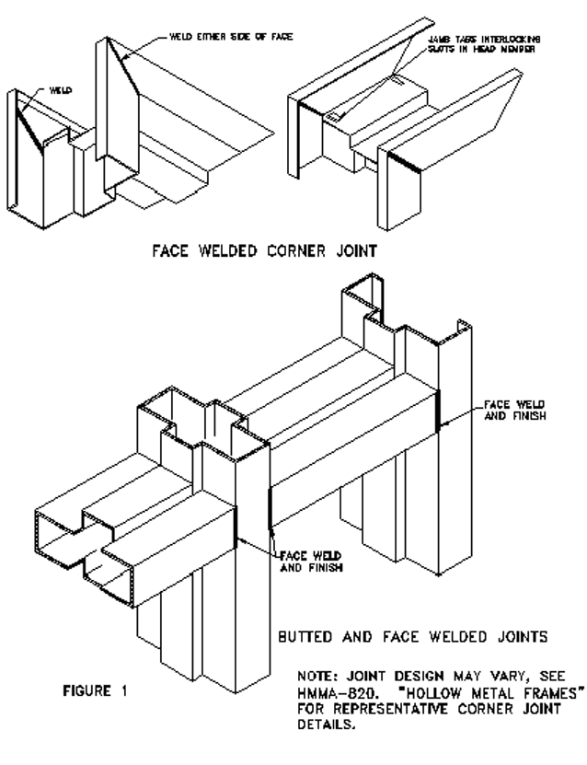

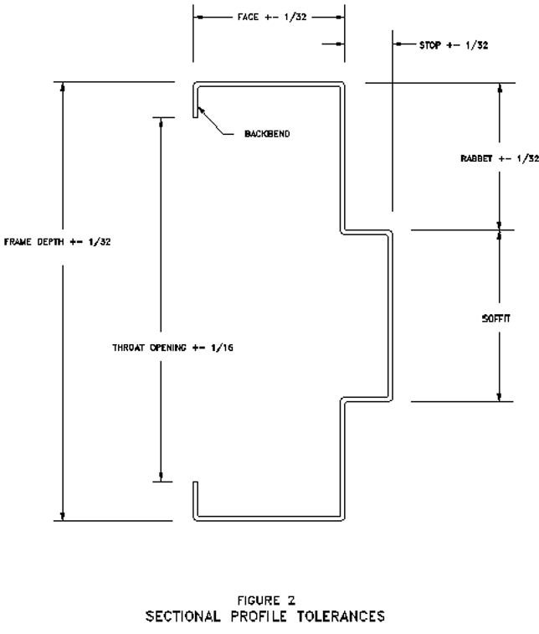

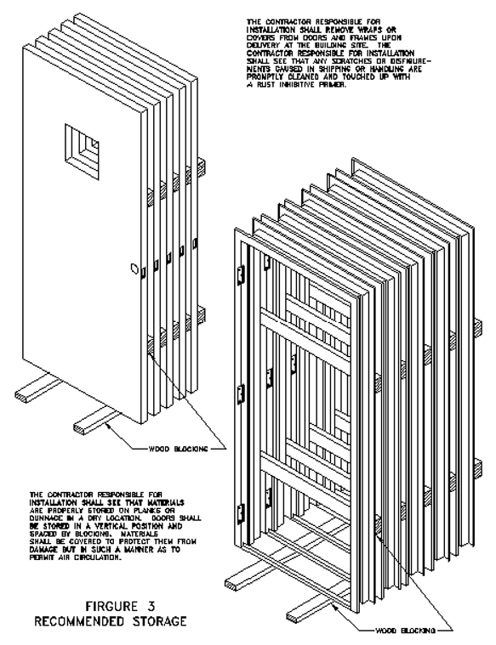

FIGURE 3
RECOMMENDED STORAGE
